Week 1 Internship Progress Report

Intern Name: Roonaq Imtiaz
Internal Supervisor: Sir Mukhtiar Zamin
Internship Organization: Allama Iqbal Open University (AIOU)
External Supervisor: Ms. Laiba Bukhari
Department: Directorate of ICT – Networks and Data Centre
Internship Domain: Cybersecurity
Week: Week 1 (13 Jan – 19 Jan 2026)

1. Objectives for Week 1
The main objective of Week 1 was to revise and strengthen foundational cybersecurity concepts, become familiar with key terminologies, and begin guided learning using recommended platforms. This week also focused on understanding basic networking concepts, common cyber threats, and security frameworks.

2. Planned Activities
- Revision of basic cybersecurity and networking concepts
- Completion of assigned terminology-based assignment
- Introduction to TryHackMe learning platform
- Self-study through online resources such as Google and Coursera
- Daily progress reporting and learning documentation

3. Work Completed / Progress Achieved
During Week 1, I successfully completed the assigned tasks and achieved the following progress:
- Explored TryHackMe and studied introductory topics related to cybersecurity, network security, web application security, and common attack methods.
- Learned and revised key terminologies including LAN, WAN, NAT, DNS, TCP vs UDP, IPv4 vs IPv6, OSI 7-layer model, OWASP Top 10, SOC, MSSP, hacking, penetration testing, sandboxing, and virtualization.
- Studied common cyber attacks such as phishing, social engineering, malware, ransomware, and password attacks.
- Completed and submitted the Week 1 assignment as per instructions.
- I began learning through Coursera by starting the Google Cybersecurity Certificate course and completed initial modules related to risk management, security frameworks, and the CIA triad.

4. Learning Outcomes
By the end of Week 1, I developed a clearer understanding of cybersecurity fundamentals, basic networking concepts, and common cyber threats. I also gained familiarity with learning platforms used in cybersecurity training and improved my ability to research and document technical concepts.

5. Certificate as proof
COURSERA:
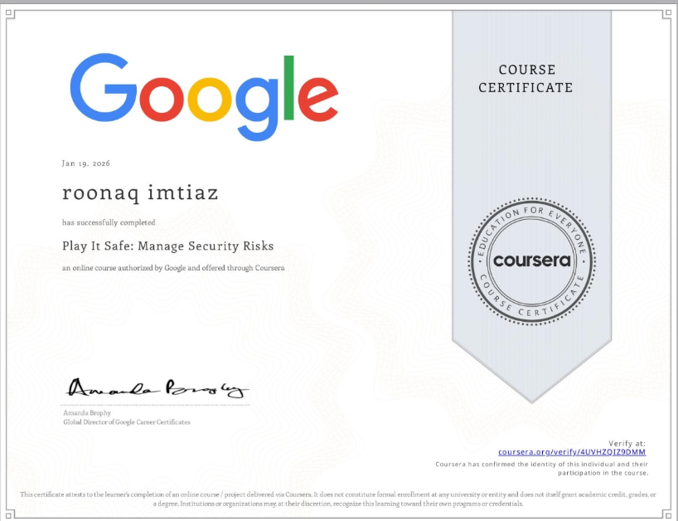
https://coursera.org/share/57e50fd5b2c58626f4684455fe24205c
TRYHACKME:
